

CARDIFF COUNCIL CYNGOR CAERDYDD
BEREAVEMENT SERVICES DIVISION ADRAN GWASANAETHAU PROFEDIGAETH
THORNHILL ROAD, RHIWBINA, THORNHILL ROAD, RHIWBEINA,
CARDIFF. CF14 9UA CAERDYDD. CF14 9UA
TEL 029 20544820 FAX 029 20544848 FFON 029 20544820 FFACS 029 20544848

WOODEN CROSS OR WOODEN MARKER
Where regulations permit, a cross or marker can be purchased for any purchased grave or cremated remains plot.

Please note - Due to weather and ground conditions, the cross or marker can only be guaranteed for a 12 month period.

Each cross or marker is supplied with a plastic plaque to accommodate an inscription. You will be advised when it has been placed.

Please set out your inscription below. Maximum of 19 letters and spaces per line over a Maximum of 4 lines.

PLEASE TURN OVER
Office use only
Cemetery: Section: Number:
Date fixed:
Signature:

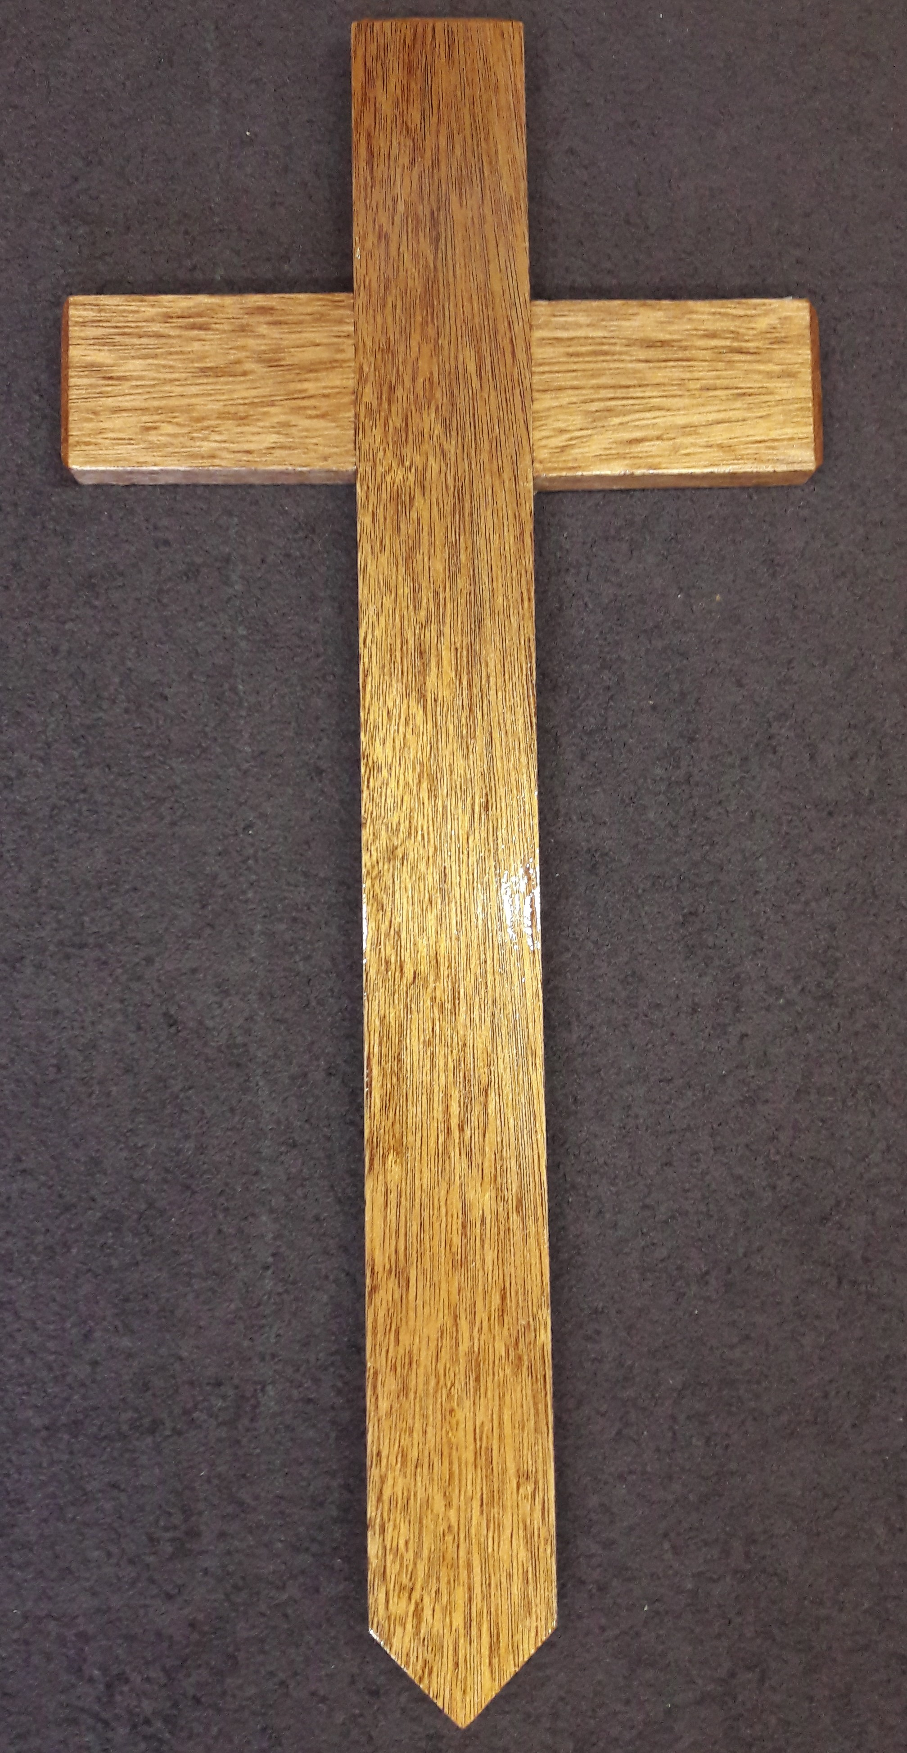 Wood colour will vary 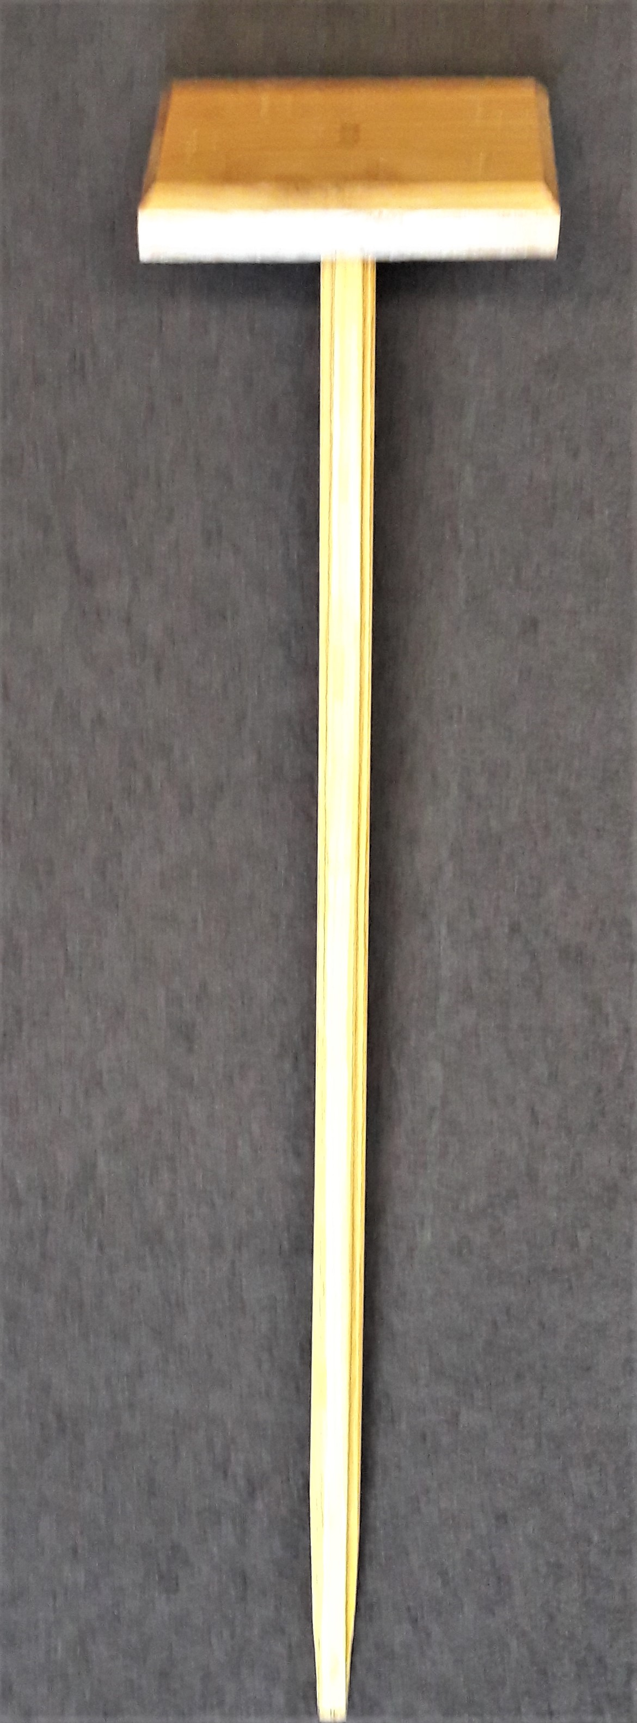

TICK ONE OPTION
□ CROSS Approx. 15” above ground £55
OR
□ MARKER Approx. 15” above ground £55

YOUR DETAILS

Name of grave owner…………………………………………………...

Address………………………………………………………………….

…………………………………………………………………………..

Postcode………………………Phone………………………………….

Signature of grave owner………………………………………………..

Date………………………………
Cheque payable to CARDIFF COUNCIL.

Note: the grave/plot number will be inscribed on a small plaque and fixed onto the cross/marker at no extra cost

Cemetery………………………… Receipt number………………….

Section…………………………… Number………………….……………

